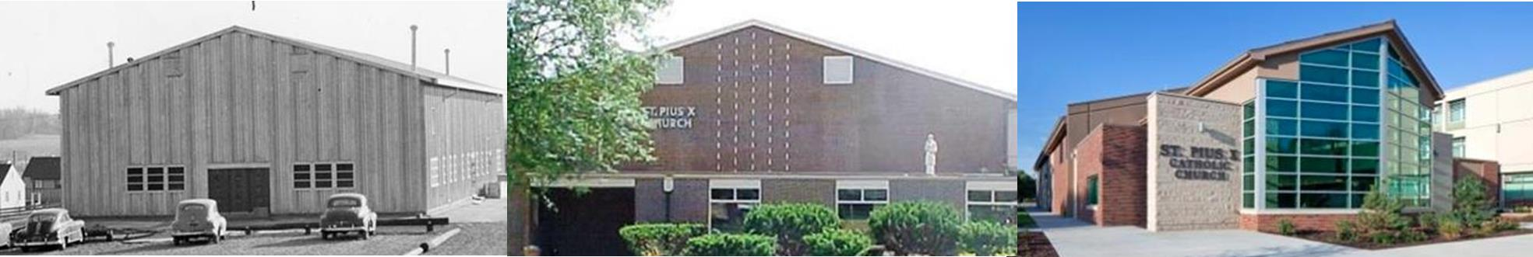
August E-News
THANK YOU ALL!! The Parish Garage Sale and the Ann’s Attic Clothing Sale were both a huge success this year. We’d like to thank our outstanding maintenance staff, Parish staff and Jolene and Brad Salt, who coordinated the delicious food for the workers. To our amazing Men’s Club and Knights of Columbus who donated funds to buy food and water to keep us all fed and hydrated, and helped with the setup and clean up-we could not do this without you! Thank you to all of the fantastic volunteers who spent countless hours with us this week. We are grateful to all who sent food and prayers, and your gently used items to fill our tables and racks. We raised over $8500 from the garage sale that benefits the parish and over $4500 from Ann’s Attic that benefits our Human Needs Outreach. In addition to helping out the parish, donations went to Thrift World, Saint Vincent De Paul Pantry, The Furniture Project, Essential Pregnancy Service, Macy Indian Reservation, Restoring Dignity and some clothes and shoes are going to Africa. The St. Pius X community is one of a kind and these sales are witness of our parish commitment to “share our gifts and resources, according to the Gospel, with a spirit of true joy.” God Bless you all!
St. Pius X Blood Drive, August 5, 7:00 am- Noon, Parish Center, Donate Blood, Help Save Lives. To schedule an appointment please call 1-800-RED CROSS of visit RedCrossBlood.org and enter St. PiusX. Sponsored by the St. Pius X Knights of Columbus and Health Ministry.
St. Pius X Parish Picnic, Sunday, August 20, 11:00 Mark your calendars for annual celebration of our parish feast day. This picnic is a long standing tradition organized by the Knights of Columbus. Hamburgers, hot dogs and baked beans will be provided. We ask that each family bring a side dish to share. Last names beginning with A-K bring desserts, and L-Z bring a side dish. We’re looking forward to seeing everyone on August 20th!

Finance
Want to be a part of a rewarding ministry? We could use your help with our St. Pius X Human Needs Outreach. We meet guests once a week on Wednesdays, between 4:00 and 5:30. You can set which Wednesdays you work. In pairs, we take turns meeting with guests, taking calls and inviting those who qualify (for rent and utilities assistance) to visit us. Retrieving calls can be done from home. You can help with both meeting with guests or taking calls or just one. This is a very rewarding ministry and a great way to help those in need. Why I am a part of this ministry? “Our faith tells us that there will always be people in need of help. At St. Pius X, we really try to embrace the perspective of “do unto others”. I find myself grateful and very blessed in being a part of the outreach we provide at SPX.”
If you are interested, contact: Nancy Lobsinger at humanneeds@stpiusxomaha.org
Health Ministry It is that time of the year to make sure your child’s immunizations are up to date before school starts. Immunizations are an important part of your child’s health. Vaccines help keep children safe from dangerous diseases as well as keep others safe if they are not able to get immunized for health reasons creating “heard immunity.” Immunizations currently prevent 2-3 million deaths per year worldwide from life threatening diseases. Vaccines have eradicated smallpox and close to eradicating polio. In the Narthex is a schedule for immunizations.
Parish children in public schools (grades 1-8) are invited to participate in the parish Religious Education program. We use a Family Formation model and meet twice monthly on Wednesday evenings. Find the registration form and details at https://www.stpiusxomaha.org/religious-education/ and call Colleen at 402-558-1898 to register your child.
Our New Guide Book and Directory will soon be mailed. In the next couple of weeks you should receive the 2023-24 directory. The advertisers helped provide this service at no cost to our parish. We encourage you to think of them in the future as your needs arise. Please familiarize yourself with the St. Pius X ministries and organizations that are listed in front of the book. A PDF version of the Guide Section will be available on our website once it is made available to us. If your information is wrong please contact the parish office so we can correct it for next year.
Parish Festival 2024 Who likes games? How will you use your gifts for this great community event? The Festival Committee is looking for new game chair-people. Basically this entails choosing the games and inflatables, ensuring that there are booth captains for each booth (school provides 8 booth captains), and making sure all the game pieces and misc. items are ready the day of the festival. We want to thank Christine Henningsen and Kate Macias for chairing this for the past two festivals. If anyone is interested please send a message to festival@stpiusxomaha.org
More Information and Details

Website
Full Calendar (includes meetings, etc.)
Ministry Guide
Facebook
Weekly Bulletin
SPSL News
Rectory Email
E-News Archives
Contact us
Digital Display in the Narthex
Not on Facebook? Posts viewable at website/publications)
Flyers, CareNotes and other information can also be found in the kiosk in the narthex of the church.
St. Pius X
6905 Blondo
Omaha, Ne 68104
402-558-8446

Please take note of Mass time changes at St. Bernard’s
